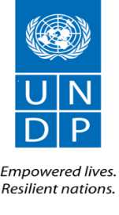
United Nations Development Programme
Country: SYRIA
Project Document

Project Title | Socio-economic stabilization and resilience building of the affected Syrian people
UNDAF Outcome(s): | Strategic Framework Outcomes (2016-2017):  Outcome 2: Basic and social services and infrastructure restored, improved and sustained to enhance community resilience  Outcome 3: Households and communities benefit from sustainable livelihood opportunities, including economic recovery and social inclusion  Humanitarian Response Plan (2016):  Objective 3: Support the resilience of affected local communities, households and individuals within the humanitarian response by protecting and restoring livelihoods and enabling access to essential services and rehabilitation of socio-economic infrastructure
Expected CP Outcome(s): | CPD Outcome 1: Households and communities benefit from sustainable livelihood opportunities, including economic recovery and social inclusion  CPD Outcome 2: Basic and social services and infrastructure restored, improved and sustained to enhance community resilience
Expected Output(s): | Output 1: Local service delivery improved and basic social community infrastructure repaired  Output 2: Socio-economic recovery enhanced for stabilization of disrupted livelihoods
Implementation: | UNDP
Partners/ Responsible Parties: | FAO, UNFPA, other specialized agencies, NGOs, CBOs among others

Brief Description
Since March 2011, the crisis in Syria has resulted in losses of human lives, significant displacement and migration, disruption in social services, destruction of basic social and productive infrastructure, homes and property, significant loss of livelihoods and deterioration in the rule of law and security. The imposed unilateral financial and economic measures, the sharp decrease in the exchange rate of the Syrian pound and capital flight to neighbouring countries have also contributed to serious deterioration in the conditions of living and soaring unemployment. A notable increase in the demand for humanitarian assistance, the erosion of assets and resources, and increasing dependency on aid have further exacerbated poverty and vulnerability in communities. This project is designed to address the increasing demands for livelihoods restoration, infrastructure rehabilitation and public services delivery and stabilisation in affected areas. It targets both internally displaced people (IDPs) and host communities who have exhausted their resources and over-stretched their coping mechanisms. The number of women-headed households has also increased due to the absence of their male partners, parents or siblings for various reasons. Special attention will be given to the needs of women, youth and people with disabilities who are often marginalized during crises. The project would contribute to strengthening the resilience of affected people for coping and eventually recovering from the consequences of the crisis. To enhance synergies and complementarities and maximize the use of resources and access to affected people, the project foresees strengthening coordination amongst the various stakeholders involved in livelihoods and early recovery, including NGOs, faith-based organisations, local authorities, other UN agencies and international organizations, and supporting advocacy for resilience building and stabilization.
Total resources required: USD 15,000,000
Total allocated resources:
- Japan: USD 15,000,000
Programme Period: One Year with possible extension
Key Result Area (Strategic Plan): Resilience Building
Atlas Award ID: ______________
Start date: April 2016
End Date: April 2017
PAC Meeting Date: n/a
Management Arrangements: DIM

Agreed by UNDP:

Agreed by Japan:

Situation analysis

Five years into the crisis, Syria is still witnessing massive destruction of infrastructure and damage to every aspect of life. Syrians are exposed daily to violence and are increasingly deprived of access to basic services due to hostilities or competition on scarce resources as a result of massive internal displacement. The appalling loss of life continues; the death toll increased during in 2015 to nearly 250,000 persons killed and the ascending trend continues. An increasing number of people with disabilities (PWDs) is reported. PWD would require special assistance as they are often marginalized during crises. Humanitarian needs are on the rise where at least 13.5 million Syrians are in dire need of humanitarian assistance including 8.7 million with acute needs of multi-sector assistance. Population displacement continues; an estimated 4.2 million refugees fled Syria, often resorting illegal and unsafe migration patterns, and 6.5 million are internally displaced, constituting as such the largest number of internally displaced persons in any country in the world. Most of the internally displaced are living with and generously hosted by communities inside Syria, despite the heavy burden that this has placed on jobs, basic services, infrastructure, and social relations.

More than 82% of the population is now living in poverty due to the crisis, with an increased rate of 57% unemployment. Total economic losses are estimated at more than 202 billion dollars. The country has lost nearly four decades of human development.

The crisis has also caused damage to housing and property, basic infrastructure, social services, and productive sectors. Shortages of fuel are affecting electricity and water supply. The disruptions to the banking services due to unilateral economic measures, the rapid shrinkage of the private sector, insecure roads hindering internal transit and trade, the rising costs of imports and inflating prices due to the devaluation of the currency affect the whole economy and most importantly the informal sector that employs a large proportion of people. Brain drain and migrant labor have increased tremendously but remittances have decreased due to the inability to make financial transactions from overseas to the country. The crisis has further aggravated the underlying causes of poverty and vulnerability. Social networks are under increasing pressure due to the limited and depleting resources of host families and local communities. Hosting communities are facing difficulties providing the necessary minimum requirements for their families, particularly that both IDPs and hosting communities have extensively relied on their diminishing savings. The number of women-headed households is increasing due to the absence of their male partners, parents or siblings for various reasons.

Since the start of the crisis in 2011, UNDP has prioritized a resilience building programme focused on area-based interventions to create emergency jobs, provide livelihoods support, restore critical community infrastructure and basic services. This will improve the living conditions of the affected population, both IDPs and host communities, and create an enabling environment for humanitarian assistance, reduce the demand for humanitarian relief, and enhance the resilience of affected communities. As the recent images of the exodus from Syria highlight, the protracted nature of the crisis has made it even more pressing to provide livelihoods and resilience based support to populations inside Syria.

Strategy
- Background
Without security, jobs, services and infrastructure, the living conditions of Syrians and their livelihoods prospects have significantly eroded, severely increasing their vulnerability and undermining their ability to cope with the crisis. The protracted nature of the crisis is also signaling further human, social, material losses, depleting national human resources and crisis response capacities and mechanisms, and leading to further displacement, including resorting to illegal or forced migration and risking death and human trafficking. Relief agencies working with Syrian refugees in neighboring countries have reported that the lack of security is not the only significant reason for displacement. A relatively large number of refugees have fled due to the scarcity of livelihoods, income, and access to basic services in their home towns and villages. This is also valid for IDPs. Thus, the urgent need to increase advocacy for comprehensive integrated humanitarian assistance programmes with a mid-to-longer-term resilience orientation, focusing not only on providing lifesaving and relief support but expanding it to livelihoods restoration, basic infrastructure rehabilitation and social cohesion preservation. This complementarity in actions contributes to the protection of the Syrian population from further destitution, equips them with necessary elements for strengthened resilience and fosters social cohesion; all leading to decent living conditions. It will also create an enabling environment for humanitarian assistance, reduce the demand for humanitarian aid, and enhance the resilience of affected communities. Syrians will then have the choice to remain anchored in their home lands, where security permits, or opt for alternative solutions seeking refuge in a more stable and secure host area. As such, and considering impact of the protracted crisis in Syria, strengthening the capacities of affected population, restoring and increasing economic opportunities and supporting service delivery in target host communities within Syria are pre-requisites for socio-economic stabilization and resilience building

UNDP remains one of the very few agencies in Syria providing this critical bridging role between humanitarian relief and development within an emergency context of conflict. Moreover, UNDP is the lead for Early Recovery and Livelihoods Sector within the UN’s Syria Humanitarian Response Plan framework.

By December 2015, UNDP contributed to the resilience of 4,438,386 Beneficiaries (805,895 direct beneficiaries and 3,632,491 Indirect Beneficiaries) through implementing 127 livelihoods restoration and infrastructure rehabilitation interventions in 12 governorates in Syria. The map below depicts the outreach of UNDP’s programme beneficiaries in 2015.

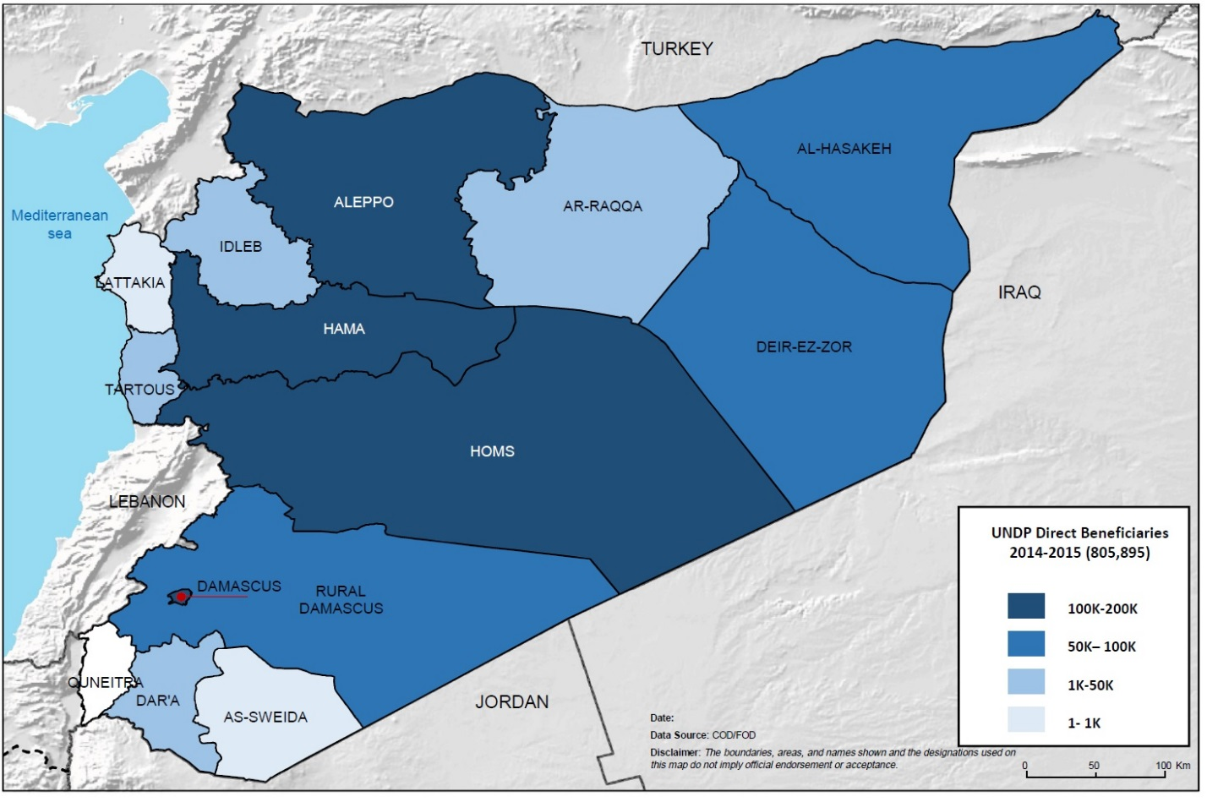

More specifically, UNDP supported the socio-economic restoration of the affected communities through reviving 663 micro to small business, availing vocational training and replacing lost assets. Additionally, UNDP created a total of 44,662 monthly employment opportunities for IDPs and their host community members in the areas of business revival, debris and solid waste management, and rehabilitation of damaged infrastructure.
Moreover, UNDP focused in developing the capacities of local partners (NGOs, CBOs and Faith-based organizations) and enhancing their participation and engagement in the socio-economic restoration and reconstruction initiatives in their communities. During 2014 and 2015, UNDP succeeded to develop and strengthen the capacities of 140 NGOs on Early Recovery programming and interventions.
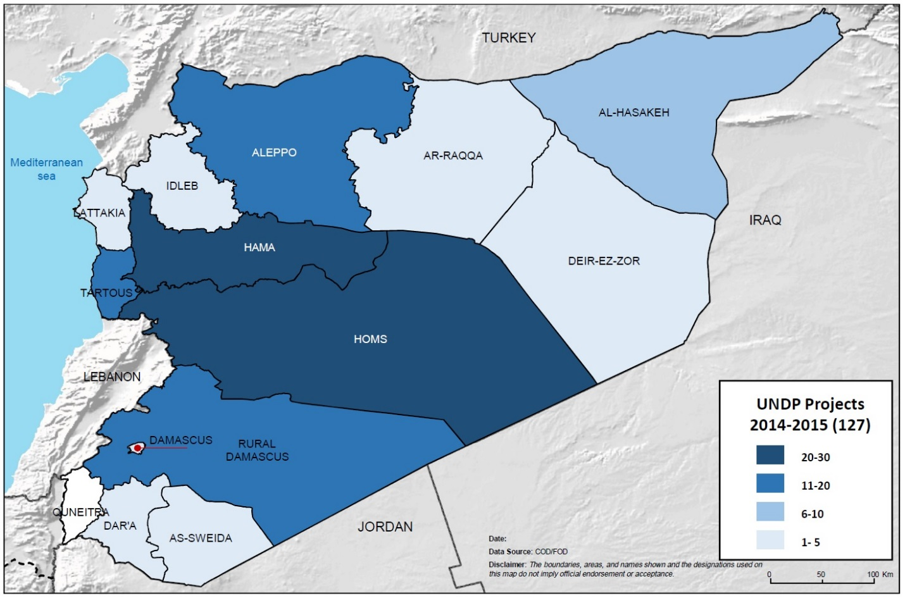

Within the UN system, UNDP is the sector lead for Early Recovery and Livelihoods in Syria engaging with more than 14 partners from UN agencies, international organizations and local NGOs within the sector forum, which works in threefold pathway: identification and assessment of early recovery and livelihoods (ERL) priority needs, planning of adequate response, and monitoring and evaluation of interventions’ results.

- UNDP – Japan project: methodology and outputs

This project falls under the overall framework of the Syria Humanitarian Response Plan (HRP 2016), the two-year UN Strategic Framework 2016-2017, and the UNDP Syria Country Programme (CPD 2016-2017); all strategically contributing to building the resilience of affected Syrian communities and populations.
For the implementation of this project, UNDP will build on its long experience in resilience building, early recovery and livelihoods to improve socio-economic conditions of the affected populations and communities.

The overall objective of the project is to provide stabilization and emergency assistance that bridges humanitarian relief with a recovery and development approach in order to strengthen the resilience of the Syrian people in the face of the protracted crisis, reducing the risk of radicalization and unsafe migration and displacement, and contributing to community stabilization. Importantly, allowing the Syrian population support to livelihoods and access to quick income generating initiatives is a significant contribution to establishing the conditions for populations to cope with the impact of the conflict while reducing the attractiveness of migration. Two major outputs are expected from this project:

Output 1: Local service delivery improved and basic social community infrastructure repaired
Output 2: Socio-economic recovery enhanced for stabilization of disrupted livelihoods

As UNDP promotes a bottom up approach to ensure inclusive participatory response planning and as part of its programming toolkit, UNDP develops Governorate Profiles capturing the main socio-economic characteristics in target governorate, priorities and needs of affected groups, partnership opportunities and potential entry points for livelihoods and resilience programming. A comprehensive livelihoods damage assessment methodology, also supported by Japan Supplementary Budget funding, was developed by UNDP in 2013/2014 and is used to identify priorities and needs in affected communities taking into consideration severity, magnitude and extent of damage in each targeted location. As such, the profiles serve to identify programmatic and operational opportunities, threats, and risks and explore available resources in the governorate in close collaboration with local stakeholders. The stakeholders mapping and analysis, which is an integral part, is crucial to better understand the socio-economic dynamics in the target governorate and ensure the inclusiveness of all concerned -including affected groups- in the local response plan. Governorate response plans are then developed; they define the scope of interventions within the framework of the UNDP mandate and the strategic objectives of the 2016 Humanitarian Response Plan. The local early recovery response plans are then translated into area-based interventions by field teams in participation with local stakeholders including NGOs, faith-based organizations and local technical directorates. This approach ensures that interventions are demand driven and locally owned as they are defined by local communities in affected areas, i.e. IDPs and host communities who exhausted their coping mechanisms due to the protracted crisis. Progress is monitored against pre-agreed targets and indicators and recorded in an Information Management System (IMS).
Based on the preliminary assessments of the most urgent needs, this project will target seven governorates namely: Aleppo, Al Hassakeh, Hama, Homs, Lattakia, Rural Damascus and Tartous where the impact of the crisis has been deemed most severe, and where major groups of IDPs are hosted, and where IDPs are returning and business can be revived. Special attention will be given to create such opportunities to women-headed household, youth and the growing number of people with disabilities (PWDs).

Output 1: Local service delivery improved and basic social community infrastructure repaired

The crisis in Syria resulted in massive destruction of infrastructure, and deterioration of basic social and municipal services. Rubble is spread in affected neighborhoods, and piles of garbage are left on the streets as basic local services are difficult to maintain. Municipal services are overstrained due to IDPs influx. On the other hand, unemployment is on the rise as many businesses have either closed down or have drastically cut down the number of workers.
Building on the results and experience of its crisis response in Syria, UNDP through this strategic partnership will work on various elements of rehabilitation focusing on basic infrastructure (such as secondary/ tertiary roads, water networks, street lighting...etc.), community and social infrastructure (such as public facilities, schools in coordination with UNICEF and healthcare centers in cooperation with UNFPA to ensure a harmonized and integrated multi-sectoral response) and commercial/productive infrastructure (business units, markets). Additionally, UNDP will work on restoration of local service delivery (such as solid waste management and rubble removal, etc.) as well as supporting renewable and alternative energy sources (such as solar LED streets lighting and solar water heating). Through these interventions, UNDP will not only improve basic living conditions in target communities but will also create job opportunities for affected populations in those areas and promote voluntarily return of IDPs to cleaner, safer and well prepared neighborhoods (where security permits). These local initiatives will target the seven governorates prioritized based on governorate profiles and continuous interaction and field assessments by field staff and local partners.

Adopting labor-intensive approach for infrastructure rehabilitation and setting-up cash-for-work scheme for local youth and IDPs will help creating income generation opportunities and ensuring local communities’ engagement, particularly youth, in debris and solid waste management and the improvement of their communities. Field engineers will provide technical assistance, follow up and daily monitoring of work. Undertaking local procurement (where possible) of safety and security outfits, tools and equipment and relying on local service providers and businesses will contribute to stimulating the local economy and reviving local markets. All rehabilitation works will be accompanied by awareness campaigns for workers and the general public on basic health and safety and hygiene. For the design and implementation of this project, UNDP will expand its partnership with UNFPA and UNICEF to establish programmatic linkages with WASH, Education, and Protection interventions to secure effective inclusion and targeting of affected population and complementarity in actions leading to better results.
To implement this component, UNDP will ensure that the following course of actions is observed throughout the implementation period:
  - Carry out rapid damage assessments in target areas to define detailed interventions plans
  - Assess the context and complement/support the existing labor intensive rehabilitation scheme
  - Procure necessary tools and equipment for rehabilitation of infrastructure
  - Repair basic and social/community/commercial infrastructure and restore basic service delivery
  - Put in place a transition plan for infrastructure and basic services restoration/management to local technical entities and provide needed technical
  - Develop and implement a capacity development programme for local actors based on needs and priorities

As UNDP promotes local ownership of local communities in the early recovery and resilience building programming and responses, capacity development plays a vital role in empowering the community representatives and civil society organizations to actually engage in such processes. Moreover, local partners are of paramount importance in connecting international humanitarian actors with affected local communities, establishing the needed delivery channels, mobilizing volunteers, and developing solutions that address the persisting needs of affected people. Therefore, UNDP will maintain its NGOs/CSOs capacity development efforts in introducing updated technical and specialized knowledge and practice that would give local partners a new panoply of options to access information, increase connections and strengthen their constituencies for better results in developing and implementing resilience building activities including community participation, youth mobilization, social cohesion, livelihoods restoration and infrastructure rehabilitation.

Output 2: Socio-economic recovery enhanced for stabilization of disrupted livelihoods

The protracted crisis has a direct impact on the livelihoods of the Syrian population including internally displaced people fleeing violence and lack of socio-economic opportunities leaving behind their productive assets, businesses and sources of income. A large number of the IDPs and affected population had to rely on humanitarian aid, savings and other coping mechanisms that are exhausted after five years of displacement. Nevertheless, humanitarian assistance does not provide enough allowances or sustained income for daily living costs and requirements. Host communities are also affected by the receding economic performance in all sectors and its impact on their livelihoods while host families have depleted their resources and savings as they have been overburdened with additional costs and responsibilities. Poverty and unemployment rates are on the rise leaving a whole country in need of emergency and humanitarian assistance and resilience building interventions. To enhance the resilience of the Syrians, restore their disrupted livelihoods and enable them gain access to a dignified source of living, UNDP provides rapid and responsive assistance through mobilizing the participation of people in the social and economic rebuilding of their communities.
UNDP’s socio-economic and livelihoods recovery programme works to stabilize livelihoods and improve the social and economic conditions required for early recovery and long-term development. It is also designed to help crisis-affected people to develop or regain sustainable livelihood assets and contribute to the revival of the local economy. UNDP’s programme focuses on vulnerable groups ensuring the priorities and needs of female-heading households, people with disability and youth are adequately addressed and the gender dimension is properly integrated.

Under this component, UNDP will contribute to strengthening the coping capacity of affected people, internally displaced people (IDPs) and host communities, to withstand and recover from the consequences of the crisis. UNDP will support the restoration of micro-to-small businesses in various governorates availing income generation and livelihoods opportunities for the most affected households so that they can secure their basic needs while also contributing to the stimulation of the local economy.
Under this specific output, UNDP will focus on the socio-economic recovery elements as follows:
Micro and small business restoration and Support: Direct support will be offered through start-up grants, restoration of small businesses and value chains, sustainable employment creation, vocational training and provision of productive assets. UNDP will ensure basic principles of accountability, transparency, and inclusiveness while ensuring a strong local engagement for better targeting, monitoring and collection of feedback from beneficiaries.
Socio-economic recovery of Youth and Female Heading Households: UNDP will pay a special attention to youth and females heading their households as a part of the most vulnerable groups in crisis times. UNDP also regards youth as main drivers of positive change, and one of the most at risk segments of the society to possibly shift into negative coping mechanisms. Support will be provided through the provision of start-up toolkits, tailored vocational training, and support/establishment of productive workshops that would provide sustainable job opportunities as well as on the job training where needed.
UNDP will also partner with FAO for its socio-economic recovery component where support to milk production in affected communities with fairly large cattle/goat/sheep population will be provided. This is essentially critical given the high nutritious value of milk contributing to the food and nutrition security of large sections of the population, and has the potential to generate additional income for households with access to markets. A range of various products can be made from milk production and processing: butter, ghee, cream, cheese, yoghurt, etc. It is envisaged to support small scale milk producers providing units for the milk collection, storage and processing together with inputs and technical advice to increase their productivity and access to markets. In addition, training will be provided in the use of equipment, technical information on nutrition and marketing.
Rehabilitation and socio-economic reintegration of Persons with Disabilities: Persons with disabilities (PWDs) are amongst the most vulnerable during crises times, and it is estimated that there is a 27% increase in the number of PWDs through the five years of crisis in Syria, reaching up to 1.5 million people suffering from different sorts and levels of disability. Among those, over 80,000 are thought to be in need of prosthetic devices as indicated in a Handicap International report. UNDP has adopted a twin track comprehensive programme that ensures:
- Enabling PWDs (enhance physical and mental wellbeing) through provision of rehabilitation services such as disability aids, wheelchairs, prosthetic devices, physical therapy occupational therapy, and psychosocial support;
- Empowering PWDs (enhance livelihood) through socioeconomic support activities such as tailored vocational training, on the job training and job placement.

UNDP will capitalize on the Japanese advanced technologies to transfer, where applicable, knowledge about innovative solutions and new technologies from Japanese institutions and/or NGOs in the field of disability aids.
To implement this component, UNDP will ensure that the following course of actions is observed throughout the implementation period:
  - Conduct technical local level assessment to identify detailed interventions plans
  - Develop and implement socio-economic recovery activities including business development services, and productive asset replacement to support micro-to-small businesses such as small industrial, agricultural and service providers.
  - Develop and deliver short-term vocational and skills development trainings and provide needed start-up kits to promote entrepreneurship and restore income generation activities. Job placements are also foreseen under this component as they proved to be an efficient modality of transfer of knowledge and capacity development for affected youth living in affected areas and host communities.
  - Provide socio-economic support to female heading households, Youth, and PWDs.

This strategic partnership between Japan and UNDP will help reaching 35,000 affected population as direct beneficiaries in the seven target governorates. Women will represent at least 30% of the total number, whereas youth will represent a minimum of 40%. 24,980 persons will directly benefit from infrastructure rehabilitation activities including employment opportunities under output 1 while 8,825 persons will directly benefit from socio-economic recovery including employment, vocational training, provision of assets and start-up toolkits under output 2. Moreover, 1900 PWD’s will benefit from provision of mobility aids, vocational training, and capacity building and finally 100 NGOs and local partners’ staff will benefit from capacity development program. The map below depicts the distribution of planned beneficiaries to be targeted across the seven governorates (this is indicative target figure and could change depending on the operational context during the implementation phase):
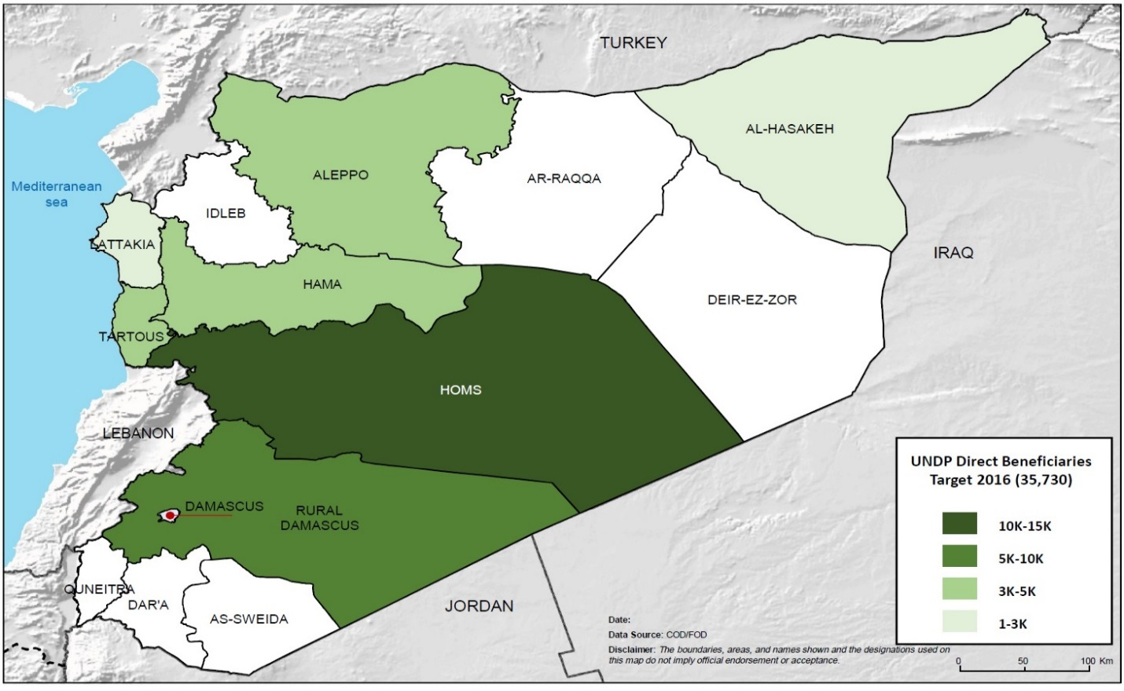
Governorate | Aleppo | Hassakeh | Homs | Hama | Lattakia | Tartous | Rural Damascus
Output 1 | 2631 | 1467 | 8764 | 3117 | 1467 | 2596 | 4938
Output 2 | 1482 | 1364 | 1799 | 1689 | 1239 | 1249 | 1928
Total | 4113 | 2831 | 10563 | 4806 | 2706 | 3845 | 6866

For the planning and implementation of this project, UNDP refers to the United Nations policy on “(Conflict) & Post-Conflict Employment Creation, Income Generation and Reintegration” and applies the three-track approach for: stabilizing income generation and emergency employment (Track A); promoting local economic recovery for employment opportunities and reintegration (Track B) and creating sustainable employment and decent work (Track C). While all three tracks avail income generation opportunities, their focus is different: livelihoods stabilization includes emergency employment schemes, targeted self-employment support especially livelihood start-up grants and packages and infrastructure rehabilitation (Track A); medium to long-term local economic recovery includes interventions that aim to boost sustainable employment, income generation, and reintegration (Track B); and long-term employment creation and inclusive economic growth (Track C). All three tracks can co-exist in any phase of the recovery but their intensity generally peaks at different times. The proposed project focuses more on the first two tracks for emergency employment and livelihoods restoration, and recovery of local economy. The identification of the needs and priorities in affected communities will be informed by the Governorate Profiles and programming-oriented assessments funded under the Japan Supplementary Budgets in 2013.
Field implementation of project activities will be executed by UNDP field teams present in targeted areas, with support from UNDP’s network of local partners. It is worth mentioning that the area based approach adopted by UNDP is not limited to needs assessments and planning, involvement of local actors continues throughout the life cycle each intervention, and in many cases goes beyond that to ensure sustainability of activities and desired impacts.

UNDP will adopt a comprehensive approach for integrated socio-economic recovery ensuring complementarity between various projects components though targeted interventions in specific geographical areas and partnerships with other agencies implementing relevant activities. For the design and implementation of the project, UNDP will capitalize on its partnership with UNICEF, WFP and UNHCR to establish programmatic linkages with WASH, Education, Food Security and Protection interventions to secure effective inclusion and targeting of affected population and complementarity in actions leading to better results. More specifically, and in order to promote the resilience-based development response to crisis inside Syria, UNDP will specifically partner with FAO and UNFPA to jointly deliver results for particularly vulnerable communities and groups such as women and farmers (for agricultural livelihoods and extended them into value-chain opportunities).

- Strategy guiding principles

As a response to the crisis, UNDP implements its resilience building programme to address main livelihoods issues of job creation, youth engagement and empowerment, women empowerment, income generating activities, access to basic and social services, coordination and capacity development of local partners. By availing livelihoods solutions and self-reliance mechanisms, UNDP contributes to the resilience-based development of the target areas, improves access to basic and social services, strengthen social cohesion, encourage youth participation and engagement in devising local solutions for the challenges faced by their communities and avoiding adopting negative coping mechanisms including resorting to violence, radicalization, armed actions and extremism, selling of assets or portraying negative social behaviors raising protection concerns (early and/or forced marriage for girls, prostitution…).
To implement its strategy and the related actions, including this project, UNDP will take into the consideration the following guiding principles:

Coherence with UN response plans: This project builds on the Humanitarian Response Plan for 2016 and links up to the Country Programme Document for UNDP 2016-2017. Additionally, this project ensures cooperation and coordination with other UN agencies operating in the humanitarian field in Syria for harmonized interventions and complementarities.
Comparative advantage: The project capitalizes on previous UNDP’s interventions in the context of the Syrian current armed conflict and on the partnerships built over time by UNDP in Syria with local technical directorates and stakeholders, in particular local associations, NGOs and CBOs in addition to various think tanks, universities and private sector. UNDP, through various previous initiatives have expanded its network of partners, gained a deep and thorough understanding of the underlying causes of the socio-economic problems in Syria, conducted focused assessments and targeted studies and developed different types of partnerships for policy making and operational implementation. This enables UNDP to have a comprehensive understanding of the changing priorities and dynamics in the social fabric and economic conditions in the country and ultimately better plan its response accordingly.
Humanitarian principles: UNDP will incorporate humanitarian and recovery principles in the design, planning and implementation of sub-projects foreseen in the present project.
Bottom-up approach: UNDP will emphasize on the role of local communities to foster the recovery process while ensuring clear linkages between micro and macro level. The project will draw on locally available capacities and strengths to implement the various local initiatives efficiently and effectively. Inclusive participation of all concerned stakeholders and beneficiaries will be sought throughout the project.
Monitoring for results: The project build on the current available strong monitoring system that ensures transparency, accountability and impartial targeting of beneficiaries and locations. This is done through a robust information management system that captures all panned activities, track the progress against indicators and assesses if the targets haven been adequately and efficiently met. UNDP will ensure coordination and consultation with concerned public institutions, as well as with other stakeholders including donors, UN agencies and others, as deemed feasible. See below section on targeting.
Conflict Sensitivity approach. Taking into consideration the root causes of the conflict, the implementation of the project will be guided by an on-going conflict analysis to better address divisive issues in communities. The implementation will be guided by the “Do No Harm Principle” and will include looking into the selection of project staff, the selection of beneficiary communities, and implementation approaches, as well as the impact of the delivered results.

- Area-based approach and Targeting

Based on existing assessments and analyses of the armed conflict in Syria, the project will work and target areas and beneficiaries with impartiality and neutrality. In doing so, the Do No Harm’ principle will be taking into account. The project will also promote impartiality, neutrality and equitability.

- Geographic targeting

UNDP plans to target the affected populations in their geographical locations as per the following criteria:

Criteria 1: Impact of the armed conflict (high number of IDPs, deteriorated basic social services, and high poverty and unemployment, etc.)

Criteria 2: Areas with potential for labour absorption/creation especially in production centres (quick assessment of economic actors may prove essential)

Criteria 3: Presence of NGOs and other partners to support implementation

Criteria 4: Areas which are relatively stable and accessible.

- Beneficiary targeting

UNDP plans to equally target all directly and indirectly affected populations. However, the project will particularly strive to target people with the most acute needs for support. To this end, the below prioritized criteria will be used to identify beneficiaries:

Criteria 1: Internally displaced people and their hosting communities
Criteria 2: People with disrupted livelihoods (housing, source of income, assets, etc.)
Criteria 3: Women-headed households (families who lost their primary income earner)
Criteria 4: People with special needs, including persons with disabilities
Criteria 5: Young people

The project will ensure that children (boys and girls) are excluded from employment and referred to suitable programmes in consultation with UNICEF and partner NGOs.

- Area-based approach

Adapting to the highly diverse situations in affected communities, UNDP has since the onset of the crisis resorted to an area-based response approach with different implementation modalities and with different types of local and international partners. UNDP is now actively operating in twelve governorates (Aleppo, Damascus, Dar’a, Deir-Ez-Zor, Hama, Al-Hassakeh, Homs, Idleb, Lattakia, Ar-Raqqa, Rural Damascus, and Tartous) either through field presence, outsourced personnel, private service providers and/or partner NGOs. The extended network of partners and various implementation modalities are essential to overcome operational and access challenges, and ensure higher flexibility in response and resilience to security and other shocks in the target areas. Work is guided by regularly updated governorate profiles, including a situation analysis of different socio-economic and vital sectors in the target governorate to update needs, priorities, local partnerships, risks and opportunities for interventions. An area-based response plan is then developed and updated in close consultation with local stakeholders under the framework of UNDP’s mandate in livelihoods, early recovery and resilience.

A conflict sensitive planning is adopted when devising the area-response plans mainly to examine the dynamics between host communities and IDPs or among the IDPs themselves. Such analysis is constantly updated by UNDP field teams and technical teams in Damascus for urgent actions and shift in the programme design. UNDP promotes for an engagement of local host communities in activities targeting IDPs by factoring a minimum of 30% of services and opportunities targeting the host communities.

Selecting the areas
UNDP develops Governorate Profiles capturing the main socio-economic characteristics in target governorate, priorities and needs of affected groups, partnership opportunities and potential entry points for livelihoods and resilience programming. A comprehensive livelihoods damage assessment methodology developed by UNDP in 2014 is used to identify priorities and needs in affected communities taking into consideration severity, magnitude and extent of damage in each targeted location. As such, the profiles serve to identify programmatic and operational opportunities, threats, and risks and explore available resources in the governorate in close collaboration with local stakeholders. The stakeholders mapping and analysis, which is an integral part, is crucial to better understand the socio-economic dynamics in the target governorate and ensure the inclusiveness of all concerned -including affected groups- in the local response plan.

Governorate response plans are then developed; they define the scope of interventions within the framework of the UNDP mandate and the strategic objectives of the 2015 Syria Strategic Response Plan. The response plans are then translated into area-based interventions by field teams in participation with local stakeholders including NGOs, faith-based organizations and local technical directorates. This approach ensures that interventions are demand driven and locally owned as they are defined by local communities in affected areas, i.e. IDPs and host communities who exhausted their coping mechanisms due to the protracted crisis. Progress is monitored against pre-agreed targets and indicators and recorded in an Information Management System (IMS).

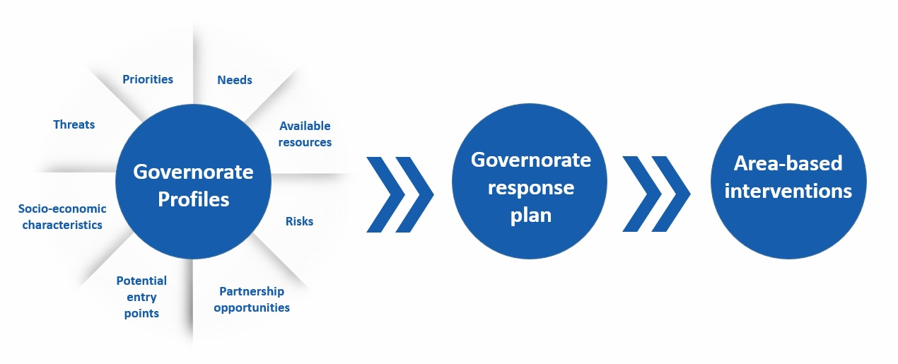
Infographic: UNDP's area-based approach

- Activities selection

Activities will be selected taking into consideration the following criteria:

Criteria 1: The selection will be guided by local rapid assessments, including on emergency livelihoods, local service delivery, basic social infrastructure status and target beneficiaries.
Criteria 2: The activities will be identified, developed and implemented in an inclusive participatory manner mainly engaging with concerned local authorities, active local committees and local stakeholders in all project development processes.
Criteria 3: Emphasis will be placed on immediate and quick rehabilitation of vital small community infrastructure that would benefit a relatively large number of people, including water, health and shelter while aiming at gauging more sustainable means for future income generation.
Criteria 4: Emphasis will be placed on activities that will employ large number of local labour and ensure rapid skills acquisition for beneficiaries to engage actively in provision of emergency assistance and repair.
Criteria 5: UNDP will endeavour that its activities are gender-sensitive and environmentally sound. Women should constitute at least 30% of the total beneficiaries.
Criteria 6: Emphasis will be placed on the “Do No Harm” principle, where UNDP activities should avoid a harmful spill-over on the individuals, the communities, the environment and the local economy.
Criteria 7: Local procurement is the most favoured option for inputs needed for the activity. UNDP shall endeavour to encourage manufacturing of tools locally to maximize the use of resources in the local market and stimulation of the local economy.

- Partnerships

The project will be implemented in close cooperation with the following partners:

  - Local technical directorates and municipal councils in target governorates (in particular for decision-making, technical skills, local coordination, implementation, supervision, monitoring and evaluation, etc.)
  - NGOs and CBOs (in particular for community mobilization, participatory monitoring, implementation, evaluation, knowledge transfer etc.). UNDP will resort to its large network of NGOs and CBOs with which there is a proven track record of joint ventures and previous partnerships experiences. Coordination will be also sought with Japanese NGOs operating in the target areas (where and when available and possible)
  - Private sector mainly for local contractors to implement labour-intensive rehabilitation and restoration activities. Innovative technological solutions will be sought from Japanese private sector where and when possible.
  - Partnerships with other UN agencies will be maintained and expanded for the ultimate benefit of the programme and consequently for higher impact on the affected populations. Having the longest presence in the country, UNDP is able to provide a wide range of support to other UN agencies and international organizations while forging new channels of collaboration for a harmonized and coordinated humanitarian and early recovery response.

In addition, coordination and synergy will be sought with Japan through existing and appropriate coordination mechanisms, and according to their respective comparative advantages and technical expertise. Moreover, harmonization of practices and knowledge management and information sharing will be sought with all partners.

Results and Resources Framework
Socio-economic stabilization and resilience building of the affected Syrian people
Applicable Strategic Plan outcome (2016-2017): Outcome 6/ Early recovery and rapid return to sustainable development pathways are achieved in post-conflict and post-disaster settings
Partnership Strategy
The project will be implemented in close partnership and cooperation with i) Local institutions; ii) NGOs/CBOs/FBOs; iii) the private sector; iv) UN Agencies, v) donors, and vi) target groups and affected population. This will promote a wider engagement of all concerned stakeholders in identification of needs, planning, decision-making, consultation, community mobilization, resource mobilization, implementation, monitoring, feedback and supervision.
In addition, coordination and synergy will be sought with bilateral and multilateral partners (donors, international NGOs, UN partners), through existing and appropriate coordination mechanisms, and according to their respective comparative advantages and technical expertise. Moreover, harmonization of practices (project selection, priority interventions wages, etc.) will be sought and knowledge management and information sharing with all partners will be considered involving the beneficiaries/target groups as well.
Project title and ID (ATLAS Award ID): Socio-economic stabilization and resilience building of the affected Syrian people
INTENDED OUTPUTS |  | OUTPUT TARGETS | INDICATIVE ACTIVITIES | RESPONSIBLE PARTIES | INPUT
Output 1: Local service delivery improved and basic social community infrastructure repaired  Baseline:  -Destruction of basic community infrastructure in target areas.  -Deteriorated basic social services in target areas, namely accumulation of solid waste (SW) and rubble  -Loss/disruption of livelihoods.  -Charity-focused NGOs/ CBOs and limited capacity to respond to early recovery needs in affected communities.  -Fragmentation and polarisation in local communities, compounded by displacement.  Indicators:  - # of jobs created  - km of basic infrastructure repaired  - # of community infrastructure repaired  - # of municipal items/equipment repaired  - Tons of SW/Debris collected &removed  - Tons of separated SW/Debris  - # of cleaned neighbourhoods  - # of Tons of compost produced  - # of tools, necessary equipment provided  - #of awareness sessions conducted  - km of streets lighted  - # of solar LED Lighting units installed  - # of solar water heating units installed  - # of people benefited from services provided  - # of Local Partners receiving specialized capacity development and training.  - # of Exchange programmes and networking conducted.  - NGO E-space in place |  | Targets :  - 1,800 job created  - 135 km of basic infrastructure repaired  - 16 schools repaired  - 7 healthcare centres repaired  - 550,000 - 600,000 people benefited from services provided  - 1,058 jobs created  - 858 municipal items/ equipment repaired  - 70,000 tons of SW collected & removed  - 14,000 tons of separated SW  - 46 cleaned neighbourhoods  - 7 awareness sessions conducted  - 250,000 - 300,000 people benefited from services provided  - 938 jobs created  - 156,250 of debris collected & removed  - 11 cleaned roads and neighborhoods  - 28,846 tons of sorted debris  - 721 tools, necessary equipment provided  - 250,000 - 300,000 people benefited from services provided  - 1,200 jobs created  - 31 km of streets lighted  - 1,250 solar LED Lighting units installed  - 1,536 solar water heating units installed  - 350,000 - 400,000 people benefited from services provided  - 100 Local Partners staff receiving specialized capacity development and training  - 4 Exchange programmes and networking conducted  - NGOs E-space functional | - Rehabilitation of Infrastructure  - Rehabilitation and maintenance of networks (electricity, water, sewage)  - Rehabilitation and maintenance of community infrastructure ( schools, healthcare centres with UNFPA)  - Rehabilitation of commercial/productive infrastructure (business units)  - Solid Waste Management  - Restoration and maintenance of the municipal services equipment and machinery  - Implementation of SW collection, Removal and Recycling activities  - Debris Management  1.3.1 Implementation of Debris/rubble Collection , Removal and Recycling activities  - Renewable Energy  1.4.1. Provision of Solar LED lightening system  1.4.2. Installation of Solar Water Heating  1.5 Support to Local Partners  1.5.1. Provide Local Partners with required capacities to engage in emergency responses with particular focus on livelihoods and early recovery and social cohesion preservation  1.5.2 Facilitate networking among local partners for sharing/exchanging information and best practice.  1.5.3 Establish e-space for local partners including NGOs/CBOs/ FBOs | UNDP, UN agencies, INGOs, NGOs, CBO’s, private sector | $ 6,500,000  2,000,000$  1,000,000$  1,000,000$  2,000,000$  500,000$
Total |  |  |  |  | USD 6,500,000
Output 2: Socio-economic recovery enhanced for stabilization of disrupted livelihoods  Baseline:  High unemployment rates  Diminished or over stretched resources of IDP’s and host communities  Loss/Damage to productive assets  High needs for vocational training to match market demand and enhance employability  Limited inclusion of youth in socio economic recovery activities  Indicators:  - # of businesses revived  - # of productive workshops established  - # of productive assets distributed  - # of jobs created  - # of people receiving vocational training  - # of start-up grants provided  - # of youth led initiatives provided with seed funding  - # of disability aids distributed  - # of disability aids production workshops established  - # of PWD's receiving vocational training  - # of PWD's receiving capacity building  - # of people receiving capacity building in the field of disability | - 30 Businesses Revived/Established  - 30 productive workshops established  - 1250 Jobs created (at least 40% for Women)  - 1800 Productive assets distributed (at least 45% for Women)  - 1100 people receiving vocational training (at least 50% women)  - 400 start-up grant provided (at least 50% for Women)  - 10 youth led initiatives provided with seed funding  - 1780 PWDs receiving disability aids  - 1 disability aids production workshop established  - 100 PWDs receiving vocational training  - 20 people benefitting from capacity building in the field of disability |  | 2.1: support to small businesses  2.1.1: Establishment/ Revival of Businesses  2.1.2: Provision of Productive Assets  2.1.3: Employment Creation  2.1.4: Provision of Vocational Training  2.1.5: Provision of Start-up Grants  2.2: Support to Vulnerable groups (Youth & FHH)  2.2.1: Establishment/ Revival of productive workshops  2.2.2: Provision of Productive Assets  2.2.3: Employment Creation  2.2.4: Provision of Vocational Training  2.2.5: Provision of Start-up Grants  2.2.6: Launch and activate Seed funding for youth led initiatives  2.3: Support to PWD's  2.3.1: Provision of disability aids (wheelchairs - prosthetics etc…)  2.3.2: Establish disability aids production workshop  2.3.3: Provision of tailored capacity building and vocational training for PWDs  2.3.4: Implementation of Capacity development programme for individuals serving in the field of disability (rehabilitation & socioeconomic support) | UNDP, UN agencies, INGOs, NGOs, CBO’s, private sector | 2,300,000$  2,500,000$  700,000$
Sub Total (Output 2) |  |  |  |  | 5,500,000 $
Technical assistance & Project Management |  |  |  |  | 1,000,000 $
Logistics & Support |  |  |  |  | 288,889 $
Security |  |  |  |  | 375,000 $
Partnerships & Reporting |  |  |  |  | 225,000 $
Sub Total |  |  |  |  | 13,888,889 $
F&A (8%) |  |  |  |  | 1,111,111 $
Grand Total |  |  |  |  | 15,000,000 $

Annual Work Plan

Annual Work Plan
Output (including baseline, indicators, annual targets) | Activities | Responsible Party | Timeframe |  |  |  | Planned budget
 |  |  | Q1 | Q2 | Q3 | Q4 | Source | Description | Amount $
Output 1: Local service delivery improved and basic social community infrastructure repaired  Baseline:  -Destruction of basic community infrastructure in target areas.  Deteriorated basic social services in target areas, namely accumulation of solid waste and rubble  -Loss/ disruption of livelihoods.  -Charity-focused NGOs/ CBOs and limited capacity to respond to current needs in affected communities.  -Fragmentation and polarisation in local communities, compounded by displacement.  Indicators:  - # of jobs created  - km of basic infrastructure repaired  - # of community infrastructure repaired  - # of municipal items/equipment repaired  - Tons of SW/Debris collected &removed  - Tons of separated SW/Debris  - # of cleaned neighborhoods  - # of Tons of compost produced  - # of tools, necessary equipment provided  - #of awareness sessions conducted  - km of streets lighted  - # of solar LED Lighting units installed  - # of solar water heating units installed  - # of people benefited from services provided  - # of Local Partners receiving specialized capacity development and training.  - # of Exchange programmes and networking conducted. local partner E-space  Target:  - 1,800 job created  - 135 km of basic infrastructure repaired  - 16 schools repaired  - 7 healthcare centers repaired  - 550,000 - 600,000 people benefited from services provided  - 1,058 jobs created  - 858 municipal items/ equipment repaired  - 70,000 tons of SW collected & removed  - 14,000 tons of separated SW  - 46 cleaned neighborhoods  - 7 awareness sessions conducted  - 250,000 - 300,000 people benefited from services provided  - 938 jobs created  - 156,250 of debris collected & removed  - 11 cleaned roads and neighborhoods  - 28,846 tons of sorted debris  - 721 tools, necessary equipment provided  - 250,000 - 300,000 people benefited from services provided  - 1,200 jobs created  - 31 km of streets lighted  - 1,250 solar LED Lighting units installed  - 1,536 solar water heating units installed  - 350,000 - 400,000 people benefited from services provided  - 100 Local Partners staff receiving specialized capacity development and training  - 4 Exchange programmes and networking conducted  - one local partner E-space | - Rehabilitation of Infrastructure  - Rehabilitation and maintenance of networks (electricity, water, sewage)  - Rehabilitation and maintenance of community infrastructure ( schools, healthcare centers with UNFPA)  - Rehabilitation of commercial infrastructure (business units)  - Solid Waste Management  - Restoration and maintenance of the municipal services equipment and machinery  - SW collection, Removal and Recycling activities  - Debris Management  - Debris/rubble Collection , Removal and Recycling  - Renewable Energy  - Solar LED lightening system  - Solar Water Heating  - Support to Local Partners  - Provide Local Partners with required capacities to engage in emergency responses with particular focus on livelihoods and early recovery and social cohesion preservation  - Facilitate networking among local partners for sharing/exchanging information and best practice.  - Establish e-space for local partners including NGOs/CBOs/ FBOs | UNDP, UN agencies, INGOs, NGOs, CBO’s, private sector | X | X | X | X | GoJ |  | 2,000,000$  1,000,000$  1,000,000$  2,000,000$  500,000$
Sub Total (Output 1) |  |  |  |  |  |  |  |  | 6,500,000$
Output 2: Socio-economic recovery enhanced for stabilization of disrupted livelihoods  Baseline:  High unemployment rates  Diminished or over stretched resources of IDP’s and host communities  Loss/Damage to productive assets  High needs for vocational training to match market demand and enhance employability  Limited inclusion of youth in socio economic recovery activities  Indicators:  - # of businesses revived  - # of productive workshops established  - # of productive assets distributed  - # of jobs created  - # of people receiving vocational training  - # of start-up grants provided  - # of youth led initiatives provided with seed funding  - # of disability aids distributed  - # of disability aids production workshops established  - # of PWD's receiving vocational training  - # of PWD's receiving capacity building  - # of people receiving capacity building in the field of disability  Targets:  - 30 Businesses Revived/Established  - 30 productive workshops established  - 1250 Jobs created (at least 40% for Women)  - 1800 Productive assets distributed (at least 45% for Women)  - 1100 people receiving vocational training (at least 50% women)  - 400 start-up grant provided (at least 50% for Women)  - 10 youth led initiatives provided with seed funding  - 1780 PWDs receiving disability aids  - 1 disability aids production workshop established  - 100 PWDs receiving vocational training  - 20 people benefitting from capacity building in the field of disability | 2.1: support to small businesses  2.1.1: Establishment/ Revival of Businesses  2.1.2: Provision of Productive Assets  2.1.3: Employment Creation  2.1.4: Provision of Vocational Training  2.1.5: Provision of Start-up Grants  2.2: Support to Vulnerable groups (Youth & FHH)  2.2.1: Establishment/ Revival of productive workshops  2.2.2: Provision of Productive Assets  2.2.3: Employment Creation  2.2.4: Provision of Vocational Training  2.2.5: Provision of Start-up Grants  2.2.6: Seed funding for youth led initiatives  2.3: Support to PWD's  2.3.1: Provision of disability aids (wheelchairs - prosthetics etc…)  2.3.2: Establish disability aids production workshop  2.3.3: Provision of tailored capacity building and vocational training for PWDs  2.3.4: Implementation of Capacity development programme for individuals serving in the field of disability (rehabilitation & socioeconomic support) | UNDP, UN agencies, INGOs, NGOs, CBO’s, private sector | X | X | X | X | GoJ |  | 2,300,000$  2,500,000$  700,000$
Sub Total (Output 2) |  |  |  |  |  |  |  |  | 5,500,000$
Technical Assistance and Project Management |  |  | X | x | x | X | Goj |  | 1,000,000$
Logistics and support |  |  | X | X | x | X |  |  | 288,889$
Security mitigation costs |  |  | X | X | X | X |  |  | 375,000$
Partnerships and reporting |  |  | X | X | X | X |  |  | 225,000$
Sub Total |  |  | X | X | X | X |  |  | 13,888,889$
F&A (8%) |  |  | X | X | X | X |  |  | 1,111,111$
Grand Total |  |  |  |  |  |  |  |  | 15,000,000$

Management Arrangements
The project will be implemented by UNDP. Management arrangements are illustrated in Figure 2 below and consist of the following key components:

- Project board chaired by UNDP with membership of the Planning and International Cooperation Committee (PICC), a representative of NGOs/ think tank, and selected UN agency(ies) as applicable (see Figure 2 below). The Project Board is the group responsible for making on consensus basis management decisions for a project when guidance is required by the Project Manager, including recommendation for approval of project revisions. Project reviews by this group are made at designated decision points during the running of a project, or as necessary when raised by the Project Manager. This group is consulted by the Project Manager for decisions when tolerances (i.e. constraints normally in terms of time and budget) have been exceeded.
- The project assurance is the responsibility of each Project Board member; however, the role can be delegated. The Project Assurance role supports the Project Board by carrying out objective and independent project oversight and monitoring functions. This role ensures appropriate project management milestones are managed and completed. A UNDP Programme Officer typically holds the Project Assurance role for the UNDP Board. The Project Manager and Project Assurance roles should never be held by the same individual for the same project.
- Project Management: The Project Manager has the authority to run the project on a day-to-day basis on behalf of the Project Board within the constraints laid down by the Project Board. The Project Manager is responsible for day-to-day management and decision-making for the project. The Project Manager’s prime responsibility is to ensure that the project produces the results specified in the project document, to the required standard of quality and within the specified constraints of time and cost. The Project Manager is appointed by UNDP.

A communication strategy will be developed for the project. It will give full acknowledgement and visibility for the donor(s), design targeted messages to manage expectations and access to information, and ensure transparency. Pictures and videos will be used to document stories from the field and project activities, in addition to publications, press releases. The Project will ensure documentation of lessons learnt and best practices.

All procurement of goods and services and recruitment of project personnel shall be carried out in accordance with UNDP rules and regulations.

Project Manager
UNDP

Project Board

Executive
UNDP

Project Assurance
UNDP

Project Organization Structure
RECOVERY AND RESILIENCE BUILDING ADVISORY TEAM:
Area Project Coordinator and team

INFRASTRUCTURE REHABILITATION TEAM:
Area Project Coordinator and team
Project Technical and Operations Support UNDP

LIVELIHOODS RESTORATION TEAM:
Area Project Coordinator and team

Figure 2: Project Organisational Structure

The project will be implemented from Damascus and through a number of field offices, depending on the security situation on the ground and the geographic areas where the needs are the most acute. To-date, there are four UN hubs in Aleppo, Homs, Qamishli, and Tartous while UNDP has field presence in additional areas of operations.

Monitoring Framework And Evaluation
A monitoring plan will be developed at the onset of the project. Monitoring of the various project activities and interventions shall be carried out through various monitoring mechanisms, including possibly the use of third party monitoring.

Additionally, the project will design an interactive database that should allow for timely reporting and facilitate monitoring of the various interventions throughout the country.

The project will encourage participatory monitoring and evaluation, to ensure the highest transparency and accountability possible.

The project manager will use as well all means of technology to maintain regular communication with the teams. S/He shall ensure that the following reporting schedule is observed:

Monthly and Quarterly progress reporting: A quality assessment shall record progress towards the completion of key results, based on quality criteria and methods captured in the Quality Management table.

An Issue Log: An issue log shall be activated in Atlas and updated by the Project Manager to facilitate tracking and resolution of potential problems or requests for change.

Risk Log: Based on the risks log (identified at the initial stage of project), the risk log shall be activated in UNDPs project management system and will be regularly updated by reviewing the external environment and internal factors that may affect the project implementation.

Field visits and quarterly reports: The Project Manager will prepare regular progress reports for the Project Management Board (PMB), accompanied by financial reports. The progress report will consist of a brief summary of progress in relation to the work plan and an update on the financial situation. This summary will also be used for feedback to the PMB for making decisions and introducing corrective actions.

Review Meetings: The Project Manager will be responsible for organizing these meetings and for following up on the recommendations and decisions taken in the meetings. The manager will prepare a brief action-oriented report on the review meeting, in coordination with the programme officer, and send it to participants in the meetings for their approval or comments.

Annual Project Report: The Project Manager will ensure the preparation of the Annual Project Report (APR), in consultation with the various stakeholders. These reports while serving the purposes of monitoring performance also will cover lessons to help in assessing the various implementation modalities, including its implications in terms of capacity building and ownership.

Annual Work-Plan and Budget: The annual work plan and budget will serve as the primary reference documents for the purpose of monitoring the achievement of results. The project manager is tasked with the responsibility of implementing the project in accordance with these documents.

Monitoring visits by UNDP: The project will be subject to monitoring visits undertaken by UNDP staff and/or an external monitoring agent who will be sub- contracted.

Lessons Learnt: A project lesson-learned log shall be activated and regularly updated to ensure on-going learning and adaptation within the organization, as well as to facilitate the preparation of the lessons-learned Report at the end of the project.

Review: Project performance will be reviewed upon completion of the project. The findings will be incorporated in the APR.

Evaluation and Audit: The project will be part of the Country office outcome evaluations. The audit of the project will be made through the regular external (UN Board of Auditors) or internal audits (audits managed by UNDP’s Office of Audit and Performance Review).

Legal Context

This project document shall be the instrument referred to as such in Article 1 of the Standard Basic Assistance Agreement between the Government of Syrian Arab Republic and UNDP, signed on 12 March 1981.

Consistent with the Article III of the Standard Basic Assistance Agreement, the responsibility for the safety and security of the executing agency and its personnel and property, and of UNDP’s property in the executing agency’s custody, rests with the implementing partner.

UNDP as executing entity shall comply with the policies, procedures and practices of the United Nations safety and security management system.

UNDP agrees to undertake all reasonable efforts to ensure that none of the project funds are used to provide support to individuals or entities associated with terrorism and that the recipients of any amounts provided by UNDP hereunder do not appear on the list maintained by the Security Council Committee established pursuant to resolution 1267 (1999). The list can be accessed via http://www.un.org/Docs/sc/committees/1267/1267ListEng.htm. This provision must be included in all sub-contracts or sub-agreements entered into under this Project Document.

ANNEXES
Annex 1
Risk Analysis

# | Description | Date Identified | Type | Impact &  Probability | Countermeasures / Mngt response | Owner | Submitted, updated by | Last Update | Status
1 | The escalation of violence and armed conflict in Damascus (UNDP CO) and/or other governorates (UNDP field presence) | Project initiation | Political (security) | Impede access and operations in specific locations/governorates or in the country (depending on intensity/scale/geographical areas)  P = 5  I = 4  (depending on available contingency measures and partnerships agreements) | - Liaise with local counterparts and increase number of partnerships for project implementation, monitoring and supervision  - Ensure adequate support to UNDP field teams to facilitate remote management  - Develop and manage partnerships with CBOs and private sector at the local level  - Identify qualified partner NGOs/CBOs for the implementation, monitoring and supervision of the project activities  - Set up a back-office in Amman to support field operations remotely (with national programme and operations staff involved on rotational basis)  - Set up a back-up office in Damascus or field locations to support the operation from within Syria  - Maintain an in-depth follow up and analysis of incidents and security situation in the country. | UNDP |  |  | Increasing in some locations in the country
2 | Inaccessibility to target areas due security situation |  | Operational | Impede operations and implementation of relevant project activities (cash transfer and distribution of tools, if procurement is not made locally or if tools are not yet distributed)  P = 5  I = 4  (Agreements with implementing partners should be in place, which will lessen the impact) | - Strengthen field teams and operations  - Rely on implementing partners at the local level (CBOs/NGOs/Private sector/local authorities)  - Third party monitoring  - Rely on available financial transfer mechanisms  - Develop strong partnerships for all of the above mentioned measures | UNDP |  |  | Highly variable in time and geographically
3 | Absorption capacity of national and local stakeholders and implementing partners |  | Operational  Organizational | Slow implementation of the planned activities due to limited capacities of national and local partners  P = 4  I = 4 | - Quick on-the-job training for target implementing partners to better implement/perform  - Develop Standard Operating Procedures (SOPs) to work with each target partner (depending on the nature/type of partnerships)  - Develop a detailed operational plan (including procurement and recruitment plans to support the implementation of activities) | UNDP
4 | Depletion of local markets and long procurement processes and approvals |  | Operational | Given the situation in Syria, prices and availability of good quality materials might be affected. International bids can be problematic given the sanctions imposed on the country.  P = 4  I = 5 | - Application of fast-track procedures for procurement  - Inform the concerned government entities of any potential international procurement to facilitate import (taking into consideration the imposed sanctions)  - Inform RACP and ACP of potential cases based on a detailed procurement plan  - Support the procurement team with an international expert. | UNDP
5 | Delay in partnerships agreement with NGOs/CBOs |  |  | Currently, partnerships with NGOs/CBOs require long procedures with the government which will delay the implementation pace.  P=4  I=5 | - UNDP senior management and partners to advocate with MoFA  - Maintain UNDP current partnership agreements approved by MoFA  - Launch clearance process well in advance of planned activities where possible. | UNDP
6 | Delay in mobilizing/ receiving required funds for implementation |  | Financial  Strategic | Delay in implementation will affect UNDP’s credibility and capability to immediately respond to the rising needs  P=4  I=4 | - UNDP will make use of existing resources to kick start implementation of project activities in target locations  - Identification of potential partners and initiation of expressions of interest should be done to shortlist/identify local CBOs/NGOs and private sector | UNDP
7 | Equal access to all affected populations |  | Political  Strategic | Negatively affect the fair and equal targeting of all affected populations  P = 4  I = 4 | - Diversification of national and local partners and target beneficiaries  - Targeting mechanisms well developed and promoting for local level engagement of all concerned stakeholders  - Continuous consultation with concerned national and local concerned stakeholders | UNDP
8 | Recruitment of highly qualified staff  - National (brain drain/ migration)  - International (security) |  | Operational  Strategic | This will affect the delivery of results.  P = 3  I = 4 | - Application of fast-track procedures.  - Pre-identifying and encouraging potentially suitable candidates to apply for vacancies.  - Look into project pools of consultants who are available and interested.

http://www.handicap-international.us/_80_000_people_in_syria_need_a_prosthesis_or_an_orthosis
Non-financial services and products offered to entrepreneurs at various stages of their business needs.

